Infinx Bulk Uploads Onboarding V1.0

Overview

The Bulk Upload function withing the Infinx Prior Authorization Software (IPA) provides the user with the flexibility to upload multiple cases at once via a .CSV file in a predetermined format.

Template Requirements

Below are the mandatory and optional fields, and standard format examples to create a case successfully in IPA.

Bulk Upload Template Do’s and Don’ts

- Ensure all mandatory fields are completed.

- Check to make sure the formats match the examples provided (specifically dates).

- Date format for Date of Service can be provided in any of the below formats.
"yyyy/MM/dd'T'HH:mm:ss" | "yyyy/MM/dd 'T'HH:mm:ss" | "yyyy/MM/dd'T'HH:mm:ss'Z'" |"yyyy/MM/dd 'T'HH:mm:ss'Z'"|"MM/DD/YYYYHH:MM:SS"| "MM/DD/YYHH:MM:SS" |"MM/dd/yyyyHH:mm:ss" | "MM/dd/yyHH:mm:ss" | "YYYY/MM/DDHH:MM:SS" | "YY/MM/DDHH:MM:SS" |"MM/dd/yyMM:SS"

- Ensure that each row has a Unique Accession Number, duplicate Accessions in the file will cause IPA to override the first Accession that was created.

- Ensure that Accessions that have been uploaded in the past are not repeated. If an Accession number is entered and it already exists in IPA then:
- If an existing case is OPEN, IPA will OVERRIDE the old case
- If an existing case is COMPLETED, IPA will CREATE a New Case with the same Accession.

- Multiple CPT’s or ICD’s should be entered in the same row for the same case.
  - Each CPT Section has 4 columns. The standard template had provision for 3 CPT’s to be added (12 Columns). If additional CPT’s need to be added, insert another section of 4 columns, copy the headers and increase the numerical value in the headers. Only a maximum of 5 CPT’s can be provided.

CPT_Code_2 | Modifier_2 | Body_Part_2 | CPT_Description_2 | CPT_Code_3 | Modifier_3 | Body_Part_3 | CPT_Description_3
74178 |  |  |  | 74160

- Each Insurance Section has 6 columns. You can add up to 3 insurances in the standard template. However, if additional Insurances are required, the below 6 columns will need to be added. Only a maximum of 5 insurances can be added.

Group_Number_2 | Group_Name_2 | Insurance_Name_2 | Insurance_Phone_2 | Member_ID_2 | Policy_Number_2
 | Group 2 | UHC Test | 909-090-9090 | 1111111 | 11

- Indicator needs to be populated with the product type. Select 1 for Prior Authorization Requests and 2 for Insurance Verification & Benefits.

- If you need to create a prior authorization case and an Insurance Verification & Benefits case for the patient, you will need to create 2 duplicate rows and tag the first row as 1 and the second row as 2 in the Indicator column.

Method of Integration

Direct Upload

Option to use the bulk upload functionality in IPA to directly upload the .csv file at your convenience. This is a simple 3 click process to upload the file.

Upload Steps

- Create the .csv file.

- Login to IPAS using your credentials.
- Select “New Case”.

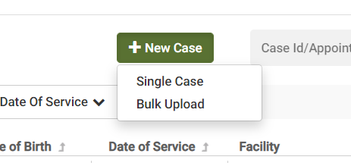

- Select “Bulk Upload”.

- On the pop-up screen, Select “Upload CSV”.
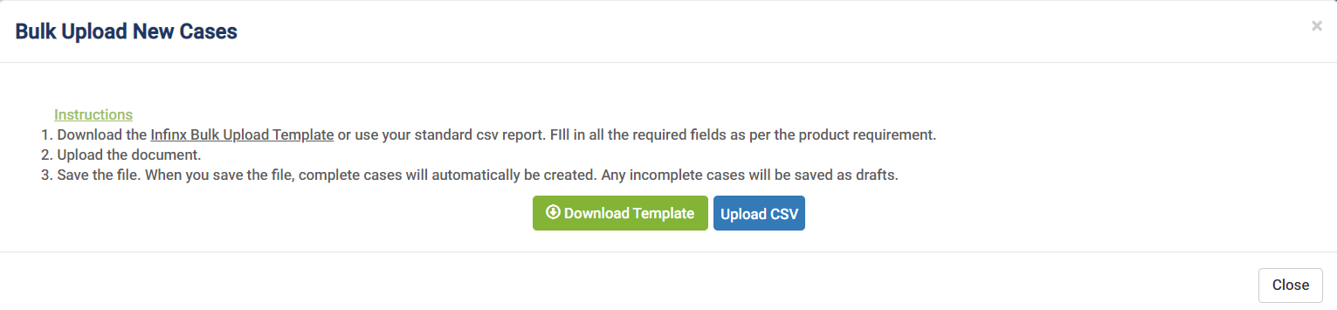

- Browse to the location of your file and open it.
- Wait for a confirmation screen to pop up confirming the success of each case. Do not close the browser. (This can take a few minutes depending on the number of cases being uploaded).
- Final status notifications:
- Successful – This is when a case is successfully created.
- Partially Successful – This implies that the case is in the Draft bucket due to some missing information.
- Failed – This status means that First Name / Last Name/ Date of Birth or Accession Number is missing.

